Name:______________________________________ Date: ____________ Period: ____
Lesson 2.2.6 Homework Problems 2-101 to 2-105
2-101. Multiply the mixed numbers.
a. b. c. d.

2-102. Below is a fast mental-math technique to find . Remember that .
a. What is one sixth of 24?

b. What is five times that quantity?

c. What is ?

2-103. Use the above method to calculate mentally each product below. Write an equation for each problem.
a. b. c.

2-104. While going on a field trip, a busload of 54 students will have to be split up into three groups. Two thirds will go to lunch first, and one third will go visit the exhibits. How many will go to lunch first? Write an equation to represent the problem.

2-105. Draw a coordinate grid. Make both the x-axis and y-axis go from –10 to 10. Then plot the following points. Label each point with its letter.
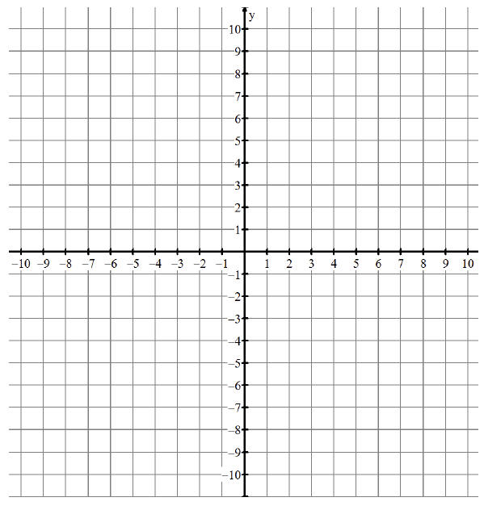
a. (−2.2, 4.64)
b. (8.2, 7.59)
c. ,
d. (0.62, −5.1)

